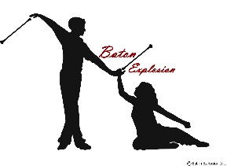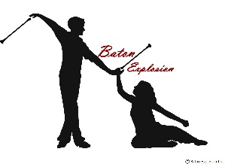

**FOREST HILL SCHOOL**

**2025 SPRING SESSION 8 WEEKS**

|  |  |  |
| --- | --- | --- |
| **DAY** | **DATE** | **TIME (S)** |
| **FRIDAY** | **April 4** | **6:00-7:00 OR 6:00-8:00** |
|  | **April 11** | **\*No Class- No school** |
|  | **April 18** | **\*No Class – Good Friday** |
|  | **April 25** |  |
| ***BNB Provincials Moncton*** | **May 2** | **\*No Class– No School** |
|  | **May 9** |  |
|  | **May 16** |  |
|  | **May 23** |  |
|  | **May 30** |  |
|  | **June 6** | **\*Fall Registration is Open\*** |
|  | **June 13** |  |
|  |  |  |
| **Next 10 Week Sessions Starts** | **September 12th** |  |

,