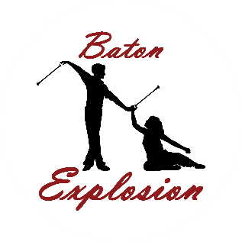
BATON TWIRLING CLASSES
FOREST HILL SCHOOL
2026 SPRING SESSION 10 WEEKS
WWWWWEEKS

DAY | DATE | TIME (S)
FRIDAY | APRIL 10 | 6:00-7:00 OR 6:00-8:00
 | APRIL 17
 | APRIL 24
 | MAY 8
 | MAY 15
 | MAY 22
 | MAY 29 | *NO CLASSES*
 | JUNE 5 | MAY 1ST
 | JUNE 12
 | JUNE 19
*Registration Open *
Next 10 Week Sessions Starts | SEPT

